**Java**

Object Oriented Development

Module 6 - Classes and Objects

© FDM Group Ltd 2020. All Rights Reserved.

Any unauthorised reproduction or distribution in part  
or in whole will constitute an infringement of copyright.

|  |  |  |  |
| --- | --- | --- | --- |
| Version | Date | Author | Comments |
| 1.0 | 26 / 10 / 20 | Nick Lawton | First draft |
|  |  |  |  |
|  |  |  |  |
|  |  |  |  |
|  |  |  |  |
|  |  |  |  |

## Creating classes

1. Create a package called com.fdmgroup.classesAndObjectsExercises. In the package create the 3 classes shown in the UML below.
   1. All void methods should simply print out a message containing the name of the method and the value of its argument(s).
   2. The readData method returns a String. The String should contain a simple message like: “data from “+file.
   3. Ensure that attributes shown in upper case are final.
   4. Create getters and setters for all attributes.
   5. Create a constructor for each class. Ensure that it only initialises the attributes shown in the UML.

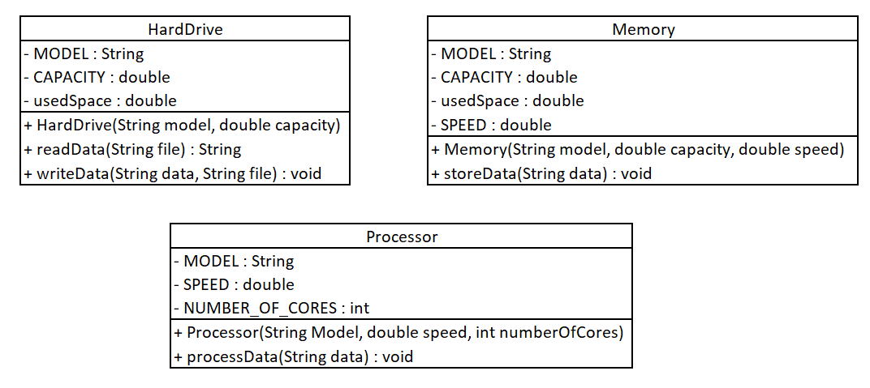

## Creating objects & calling methods

1. Create a class called Runner with a main method.
2. Inside the main method make the objects listed below from the classes you just created and use their constructor to set their member attributes to the values specified below.
3. Call the getter methods on each object and print out their return values to verify that its attributes have been initialised correctly.
4. Change the value of drive1’s usedSpace variable by calling the setUsedSpace() method passing in the value 50.
5. Call the getUsedSpace() method on drive1 and print out its return value. Verify that this is 50.

Hard drives:

**drive 1**

Model: Seagate

Capacity: 2 TB (2048 GB)

Used: 0 GB

**drive 2**

Model: Dell

Capacity: 3TB (3072 GB)

Used: 500 GB

Processors:

**processor 1**

Model: Intel Xeon

Cores: 6

Speed: 2.93

**processor 2**

Model: Intel Celeron

Cores: 2

Speed: 2.9

Memory:

**memory 1**

Model: Kingston

Capacity: 4 GB

Speed: 1600

**memory 2**

Model: Corsair

Capacity: 8GB

Speed: 1333